Fault-Tolerant Systems
# Source: AI Source: Provided by: [Data Path: Persons Table -> ID Column: 1, Name_En Column: Motasem Essam] -> From: [ChatGPT] on [1/16/2026]
A Fault-Tolerant System is a type of distributed system designed to continue operating correctly even if some of its components fail.
These systems are critical in mission-critical applications where downtime or errors can cause significant problems, such as in banking, aviation, healthcare, or nuclear control systems.

Definition
# Source: AI Source: Provided by: [Data Path: Persons Table -> ID Column: 1, Name_En Column: Motasem Essam] -> From: [ChatGPT] on [1/16/2026]
A Fault-Tolerant System:
- Detects and handles hardware or software failures automatically
- Ensures continuous service availability
- Uses redundancy, replication, and error recovery to prevent system crashes

Architecture Diagram
# Source: AI Source: Provided by: [Data Path: Persons Table -> ID Column: 1, Name_En Column: Motasem Essam] -> From: [ChatGPT] on [1/16/2026]
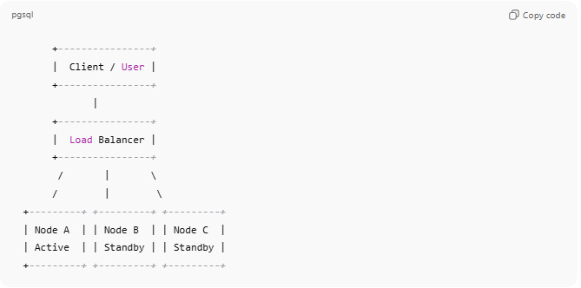
+----------------+
| Client / User |
+----------------+
|
+----------------+
| Load Balancer |
+----------------+
/ | \
/ | \
+---------+ +---------+ +---------+
| Node A | | Node B | | Node C |
| Active | | Standby | | Standby |
+---------+ +---------+ +---------+
- Active node: Handles main tasks
- Standby nodes: Take over automatically if active node fails
- Load balancer or failover mechanism ensures uninterrupted service

Key Characteristics
# Source: AI Source: Provided by: [Data Path: Persons Table -> ID Column: 1, Name_En Column: Motasem Essam] -> From: [ChatGPT] on [1/16/2026]
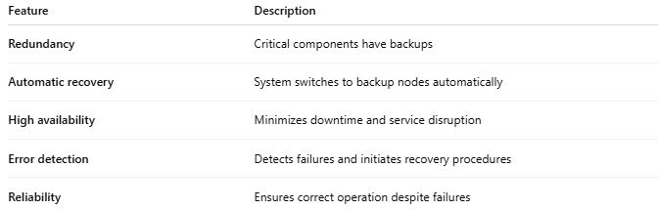
Feature | Description
Redundancy | Critical components have backups
Automatic recovery | System switches to backup nodes automatically
High availability | Minimizes downtime and service disruption
Error detection | Detects failures and initiates recovery procedures
Reliability | Ensures correct operation despite failures

How It Works
# Source: AI Source: Provided by: [Data Path: Persons Table -> ID Column: 1, Name_En Column: Motasem Essam] -> From: [ChatGPT] on [1/16/2026]
- Components continuously monitor each other
- If a failure is detected, the system activates redundant components
- Tasks continue without user noticing disruption
- Failed components are repaired or replaced while the system runs

Advantages
# Source: AI Source: Provided by: [Data Path: Persons Table -> ID Column: 1, Name_En Column: Motasem Essam] -> From: [ChatGPT] on [1/16/2026]
- Continuous service with minimal downtime
- Reliable and robust for critical applications
- Can handle hardware and software failures simultaneously
- Often combined with replication and load balancing

Disadvantages
# Source: AI Source: Provided by: [Data Path: Persons Table -> ID Column: 1, Name_En Column: Motasem Essam] -> From: [ChatGPT] on [1/16/2026]
- High cost (requires redundant hardware/software)
- Complex system design and maintenance
- May require more resources for replication and backup
- Recovery mechanisms can add overhead

Examples
# Source: AI Source: Provided by: [Data Path: Persons Table -> ID Column: 1, Name_En Column: Motasem Essam] -> From: [ChatGPT] on [1/16/2026]
- Banking transaction systems
- Air traffic control and aviation systems
- Nuclear power plant control systems
- Cloud infrastructure with HA clusters (AWS, Google Cloud)

Simple Analogy
# Source: AI Source: Provided by: [Data Path: Persons Table -> ID Column: 1, Name_En Column: Motasem Essam] -> From: [ChatGPT] on [1/16/2026]
- Fault-Tolerant System: A plane with multiple engines
  - If one engine fails, the others continue to keep the plane flying safely
  - Passengers (users) hardly notice any problem

